LAB #7 — REPORT

EAPS 577

39 points possible

NAME: Kris Laferriere

(1) Paste your true color and enhanced color visible wavelength images (of the entire image) below [2 pts]:

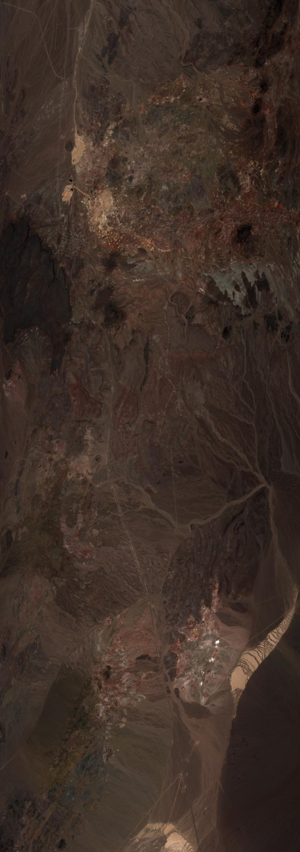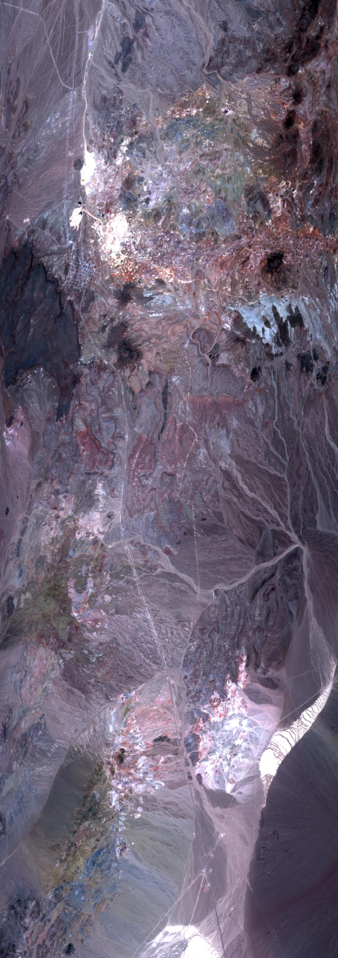

(2) Plot your data.

1. Paste your plot below. [1 pt]:

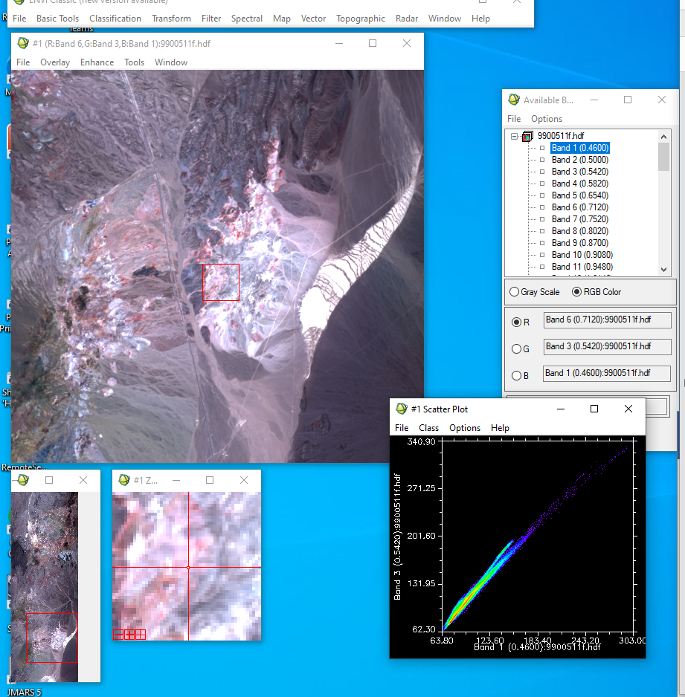

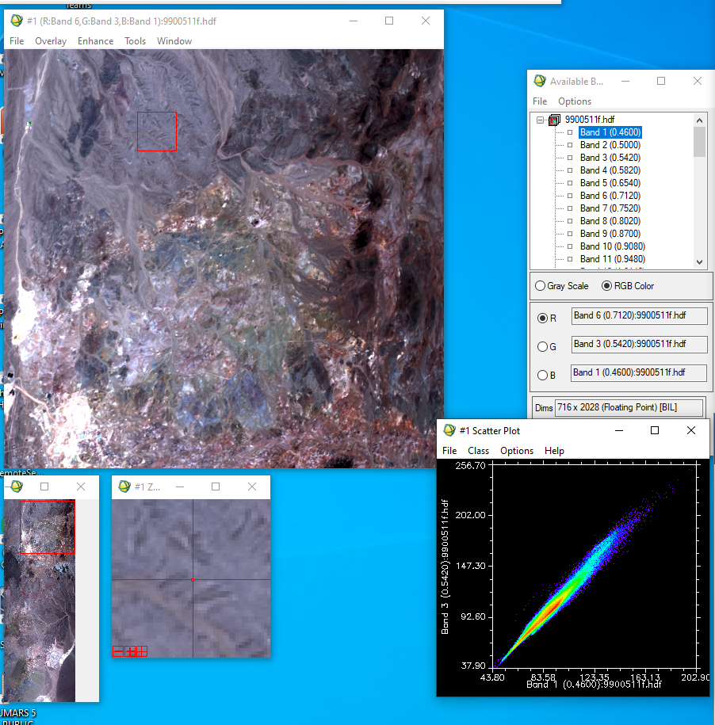

1. How can you tell that these two bands are highly correlated? [1 pt]

These two bands are clearly highly correlated as the plot directly along an x/y line

(3) Examine your PC’s.

1. Paste the grayscale image for each PC in your report, and make sure to label each one. [1 pt]:

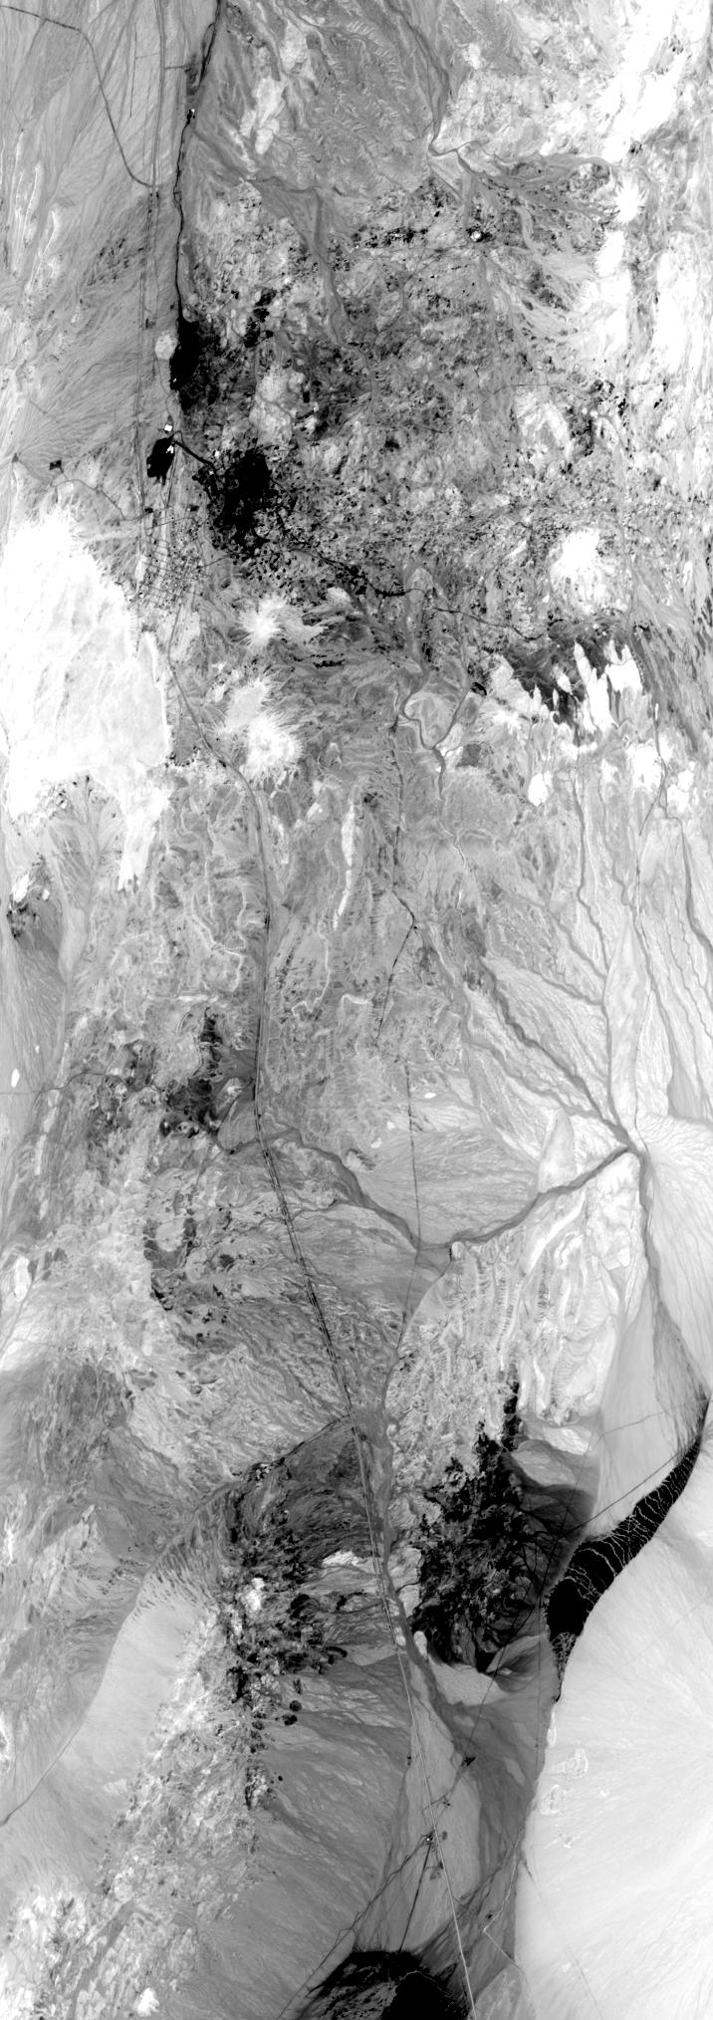band 1

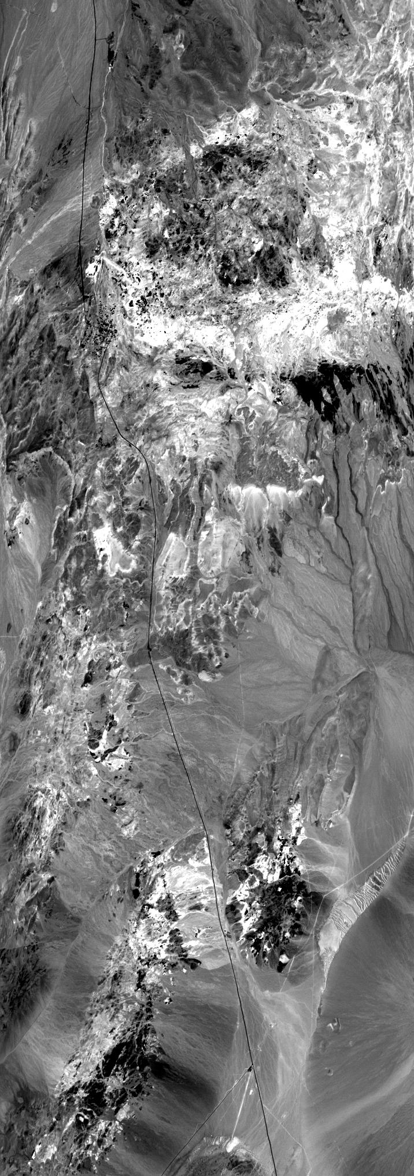band 2

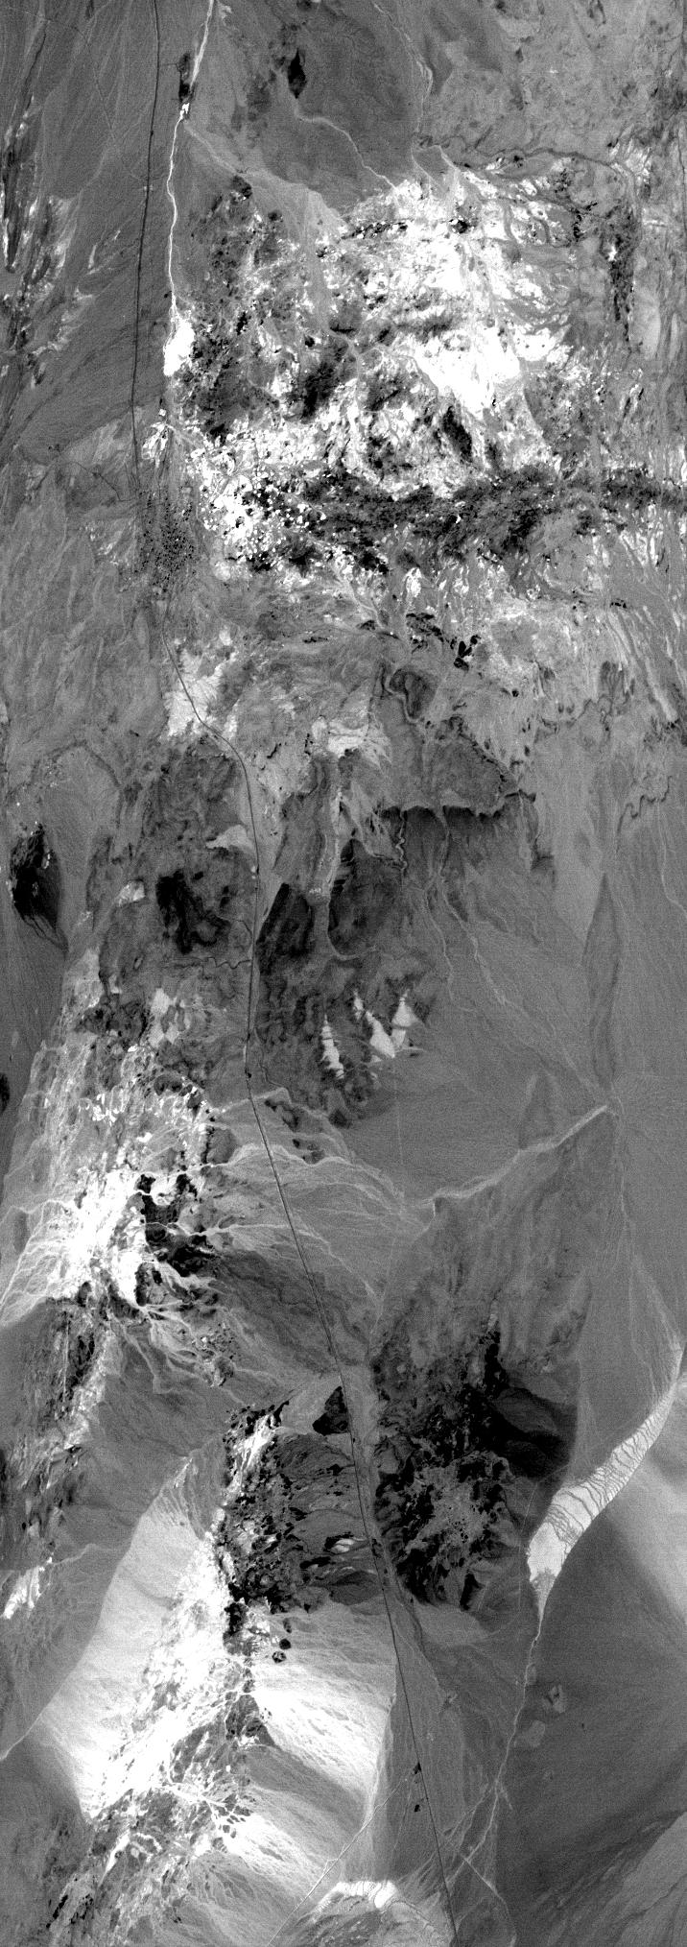band 3

1. What physical characteristic of the surfaces in the scene is PC1 of the visible color bands mainly showing and how can you tell? Make sure you address: what does bright vs. dark in PC1 mean when compared to the original data? [2 pts]

Looking at colaprete – dark is where the bright white used to be in the original 6/3/1 RGB. Where the correlated colors were? In PC band 2, this is mixed bright and dark. In PC band 3 it is dark again. The slope feature to the right of colaprete which in 6/3/1 looked dark with a bright feature above in band 1 is now light gray with a dark feature, band 2 is gray with a lighter gray feature. And in band 3 dark gray with a white feature.

(4) PCA eigenvalues

1. Using their eigenvalues as a fraction of their total, estimate the ***percentage*** of the variance that is captured in PC1, PC2, and PC3. [2 pts]

Basic Stats Min Max Mean Stdev Num Eigenvalue

Band 1 43.799999 303.000000 86.518893 12.548711 1 847.181855

Band 3 37.900002 340.899994 96.382786 18.314086 2 12.086821

Band 6 29.600000 283.200012 94.819194 19.185029 3 1.672564

% variance in PC1: 847/86 = ~ 100

% variance in PC2: 12/96 = ~ 10

% variance in PC3: 1/94 = ~ 0.01

1. Based on your answer to Question 3b, why does this make sense? [1 pts]

I do not know.

(5) PC images

1. Paste your PCA RGB image below. [1 pt]

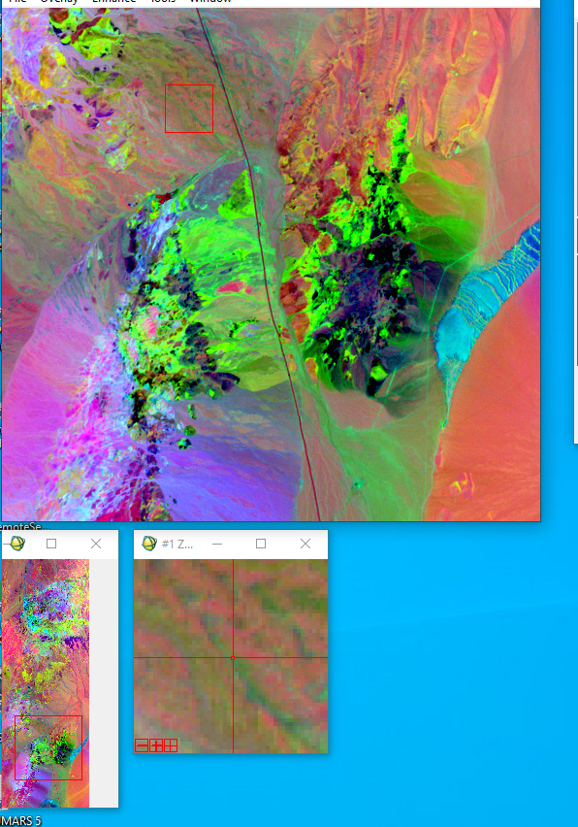

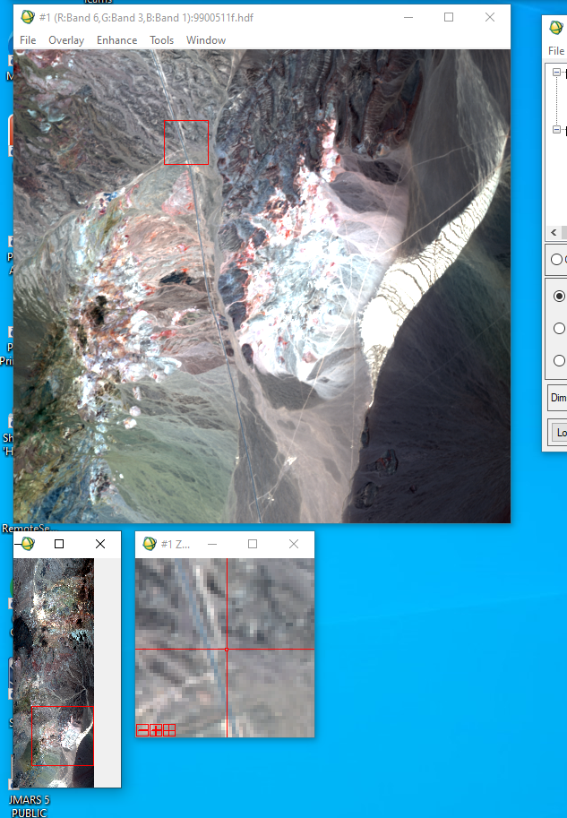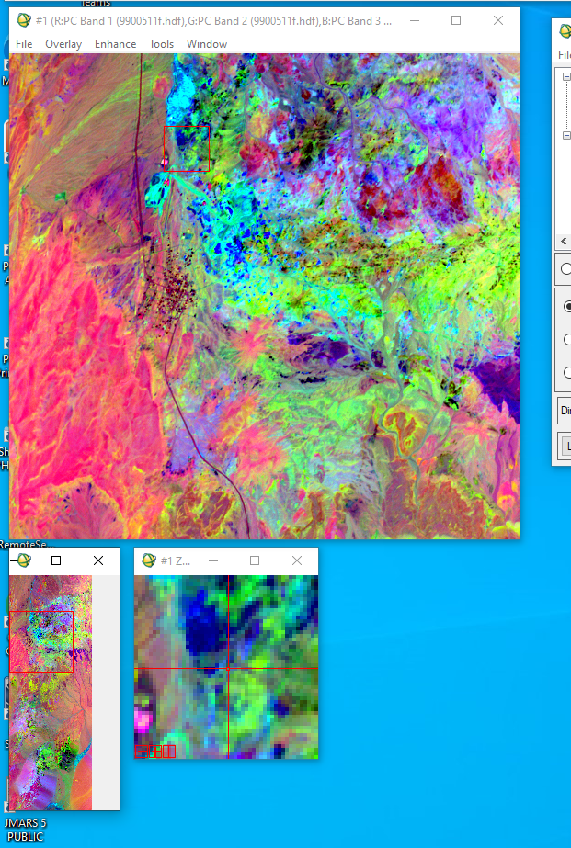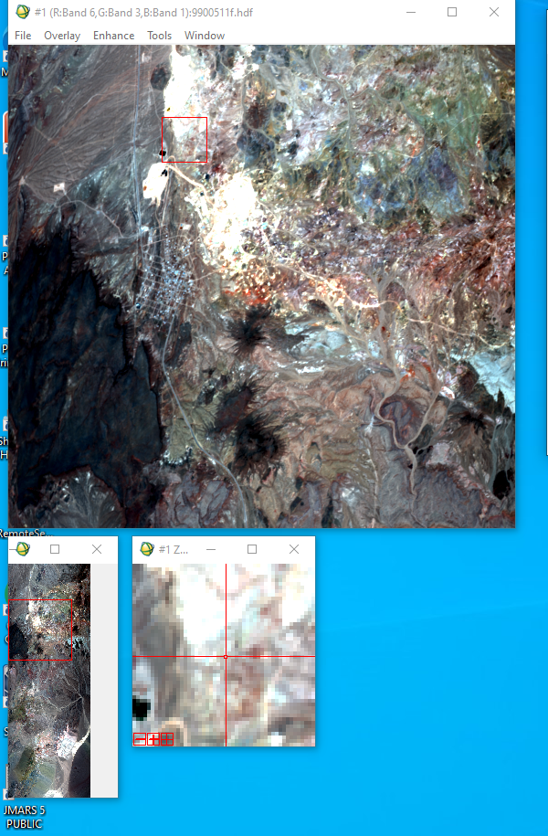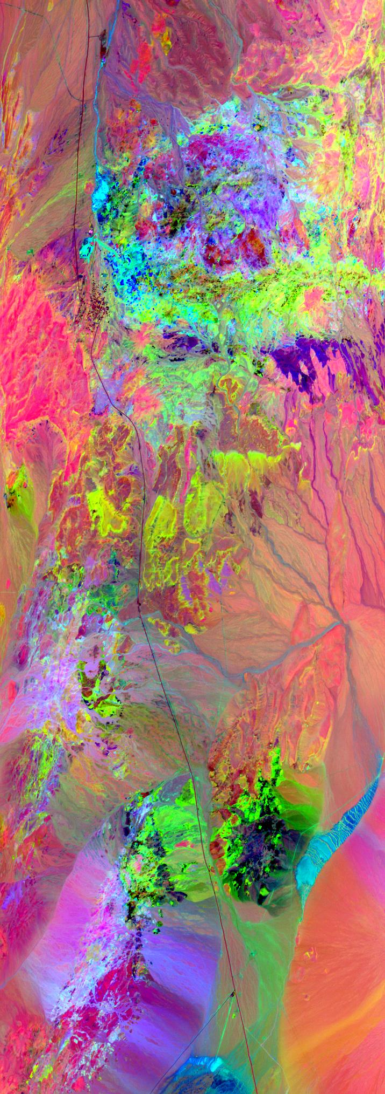

1. How does this new image compare to the original stretched RGB? Can you see variability that wasn’t apparent before? Use screenshots, save image subsets from in ENVI, or cropped versions of your images above to ***demonstrate and discuss*** at least one area where more variability is apparent. [4 pts]

No idea

1. Paste your PC scatter plot below. [1 pt]

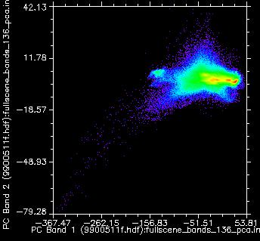

1. Compare this plot to your plot of the visible bands in Question 2a. How is the enhanced variability in the image represented in the scatter plot of the PC’s? [1 pt]:

Still no idea

(6) Mapping alteration

1. Paste your chosen PC RGB combination below. [1 pt]
2. Compare your PC RGB to the alteration map in Figure 5. Does your RGB combination capture the variability in alteration mineralogy? Are there some minerals that you can’t differentiate? [2 pts]
3. What colors in your chosen image correspond to which alteration zones? [3 pts]

(7) Visible wavelengths DCS

1. Paste your normal stretched color RGB of cuprite below [1 pt].
2. Paste your DCS RGB below [1 pt]
3. How does the DCS image compare to the original RGB image of these bands? How have the colors in the image changed? Is there a color change that surprised you? [2 pts]

(8) Thermal wavelengths DCS

1. Paste your RGB combination of bands 42/44/47 below [1 pt]
2. Paste your plot of bands 42 vs. 47 below [1 pt].
3. Paste your DCS of bands 42/44/47 below [1 pt].
4. Paste your plot of the red vs. blue DCS bands below [1 pt]
5. What is the effect of the decorrelation stretch on the plot compared to the original data? Can you see the original distribution of the original data reflected in the DCS plot? [1 pt]

(9) Based on the geologic map, identify the composition of these units in your DCS

(a) The yellow splotch in the DCS map near to the left of center in the scene? [1 pt]

(b) The large blue mountainous region to the center right of the scene? [1 pts]

(c) The green flat area on the far right of the scene? (Hint: what do you expect to be present in this type of landform?) [1 pts]

(10) Compare your VNIR/SWIR DCS image of choice from Question 7b to the mid-IR DCS. This area is a combination of exposed bedrock, hydrothermal alteration zones, sediments, and other landforms, as shown in the geologic and alteration maps.

1. Which wavelength range does a better job discriminating bedrock? From lecture, what major absorption band is this region detecting, and why would this band vary across the scene? [3 pts]
2. Which wavelength range does a better job discriminating alteration? (We’ll learn about why this is next week!) [1 pt]